Terminal Data including: Attendance records and user enroll data

I: Synchronize User Enroll Data to different Time Attendance Terminals

Transfer the User Enroll Data from one Terminal to another Terminal, so the user can verify from both the terminals. Following is the description on how to use the BS API (WebSocket API) to synchronize User Enroll Data to different Terminals.

**1. First of all, when the Terminal connect to the Cloud System, it reports the Serial Number of the Terminal, the Cloud System would divide several Terminals to one Group.**

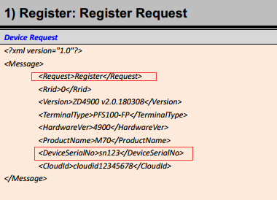

**2. Assign the User ID and User Name etc. basic User Information to all the Users. (Not including the Fingerprint Template and Face Template.), It will generate a List. Then Upload all the User Information to all the Terminals that inside the Group one by one through the command “SetUserData”.**

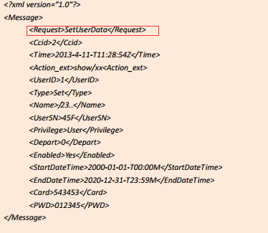

NOTE:

1) <Enabled>Yes/No</Enabled> this is to determine if the User is resigned or not

: Yes: User data is normal, can verify on the Terminal

: No: User is resigned, the User Data keeps on the Terminal, but this User cannot verify on the Terminal any more.

**3. When the User register the Face Template, Fingerprint Template and ID card from any one of the Terminals that inside the Group, the Terminal will auto upload a “AdminLog” to the Cloud System and tell you that what this User registered and from Which Terminal.**

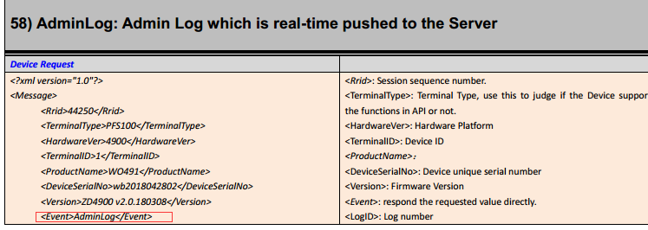

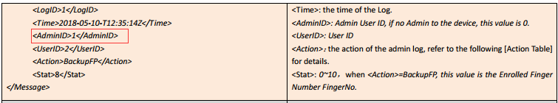

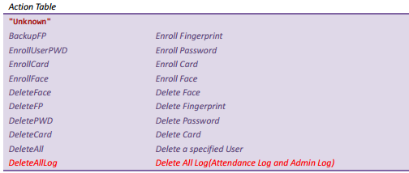

NOTE: TimeLog and AdminLog interface, Server must reply the correct value, otherwise, the Terminal will keep sending the data again and again, until the Server reply the correct value. Rrid(device to server )=Actid(server to device);Ccid(server to device)= Actid(device to server).

**4. from the Terminal with AdminLog, Get the User’s Fingerprint Template, Face Template or ID card number, and save via command GetUserCardNo , GetFingerData, GetFaceData**

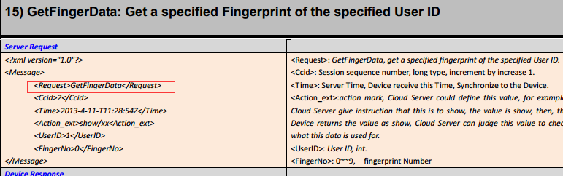

**5. for the data we received just now, Upload to other Terminals that inside the same Group through command SetUserData, SetFingerData, SetFaceData.**

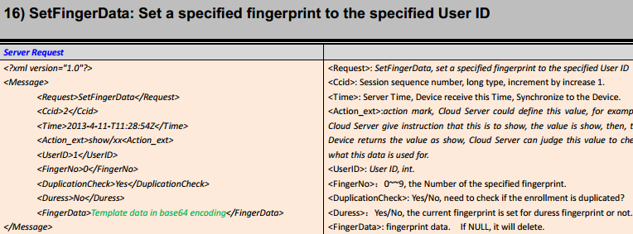

**6. the User can verify from any one of the Terminals that inside the same Group.**

NOTE:

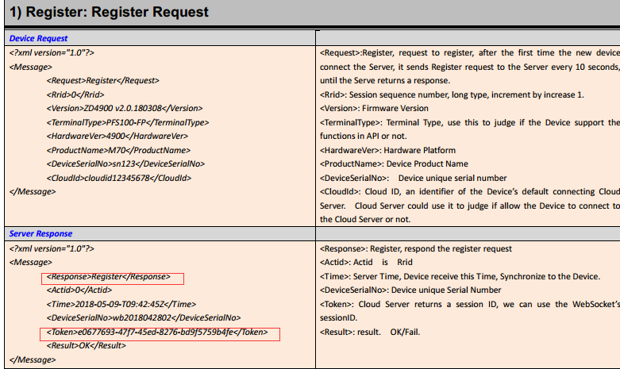

Command “Register” will be sent to the Cloud System by one time, judging if the Terminal is your Terminal by the CloudID. The Cloud System reply Token value, this value will keeps on the Terminal, when the Terminal re-connect to the Server in future, it will skip this register step, and direct login, and upload the token value. When we initialize the Terminal setting, and Terminal connect to the Cloud Server, it will send the register request again.

II: Getting the Attendance record

Each time when the User verify success on the Terminal, the Terminal will auto sending a TimeLog to the server, it includes the User information, after statistics it, it will generates a Report.

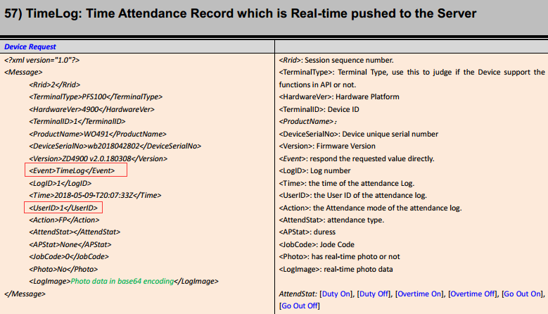

NOTE: TimeLog and AdminLog interface, Server must reply the correct value, otherwise, the Terminal will keep sending the data again and again, until the Server reply the correct value. Rrid(device to server )=Actid(server to device);Ccid(server to device)= Actid(device to server).